**CN Lab Experiment 1**

**Objective:**

* To familiarize students with Cisco Packet Tracer.
* To set up a peer-to-peer (P2P) communication network.
* To study different types of network cables and their color codes.
* To document the observations and save the configuration file in a GitHub repository.

**Requirements:**

* Cisco Packet Tracer software.
* A GitHub account and a repository for lab assignments.
* Access to Google Classroom for submission.

**Part 1:**

**Instructions:**

* Ensure you have Cisco Packet Tracer installed on your computer. If not, download it from the Cisco Networking Academy website.
* Open Packet Tracer and explore the user interface. Familiarize yourself with different tools and components available in the software.
* Open Packet Tracer and create a new network.
* Add two PCs to the workspace.
* Use a copper straight-through cable to connect the FastEthernet0 port of PC0 to the FastEthernet0 port of PC1.
* Assign IP addresses to both PCs:
* PC0: IP address: 192.168.1.1, Subnet Mask: 255.255.255.0
* PC1: IP address: 192.168.1.2, Subnet Mask: 255.255.255.0
* Open the command prompt on PC0 and ping PC1 using the command ping 192.168.1.2.

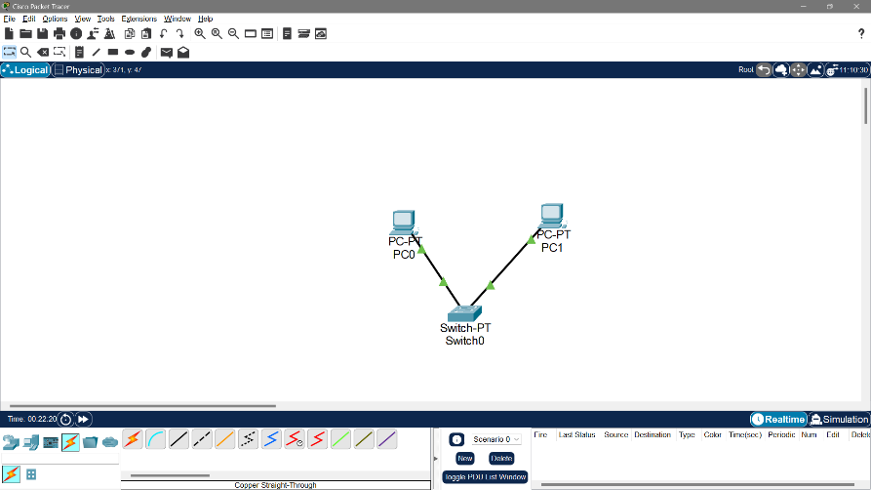

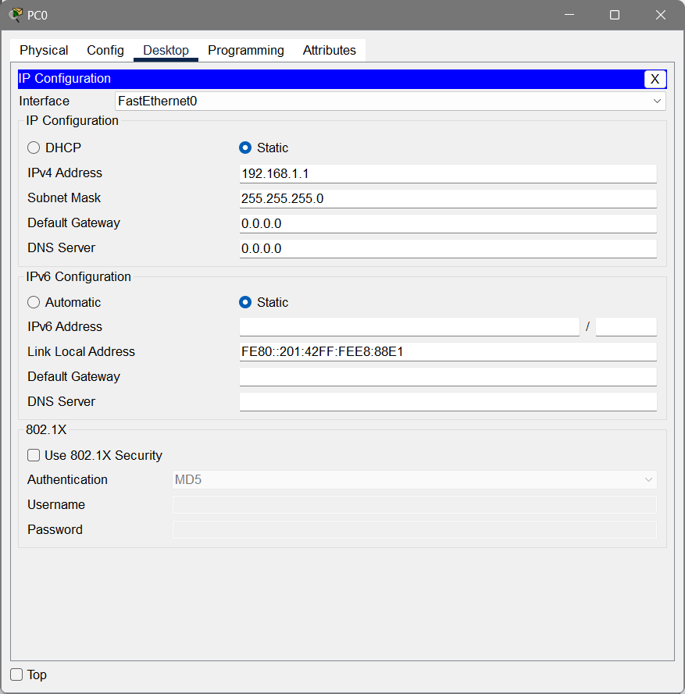

**Results:**

* Successfully connected both the desktops to a network.
* Pinged the other desktop by Peer-to-peer connection.

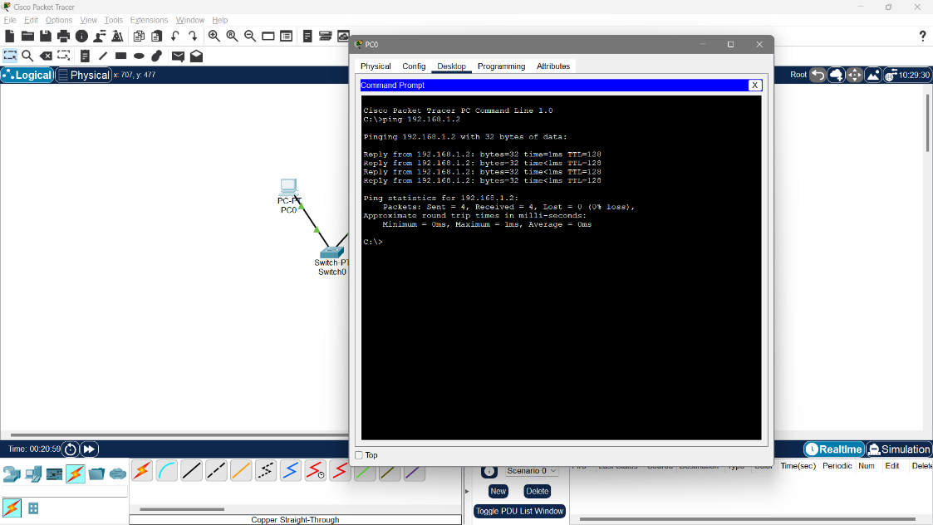

**Part 2:**

**1. Copper Straight-Through Cable**

**Description:** A copper straight-through cable is perhaps one of the most commonly used network cables. It’s characterized by the same pin configuration at both ends, meaning the wires in the cable are connected straight through from one end to the other.

**Use Cases:**

* Connecting a PC to a switch or hub.
* Linking a router to a switch to enable communication between different network segments.

**2. Copper Crossover Cable**

**Description:** Copper crossover cables, on the other hand, feature different pin configurations at each end. These cables are designed for connecting similar devices directly to each other, bypassing the need for intermediary networking equipment.

**Use Cases:**

* High-speed, long-distance connections in data centers and telecommunications.
* Environments with high levels of electromagnetic interference.

**4. Console Cable**

**Description:** Console cables are employed for connecting a computer to the console port of a network device, such as a router or switch. These cables are typically serial and facilitate access to the device’s command-line interface (CLI) for configuration and management.

**Use Cases:**

* Configuring and troubleshooting network devices.
* Initial setup and recovery of devices.

**5. Serial DCE/DTE Cable**

**Description:** Serial Data Communications Equipment (DCE) and Data Terminal Equipment (DTE) cables are used for serial communication between devices like routers and switches. These cables have different pinouts at each end, with one end acting as the DCE and the other as the DTE.

**Use Cases:**

* Interconnecting routers in a serial network (common in Wide Area Network configurations).
* Connecting switches with serial interfaces for specific functions.

**6. Wireless Connections**

* **Description:** Wireless connections are used to connect devices without the need for physical cables. They utilize radio waves to transmit data between devices, such as laptops, smartphones, tablets, and wireless access points (WAPs). Wireless networks can operate in various frequency bands, most commonly 2.4 GHz and 5 GHz, providing flexibility and mobility in network design.
* **Use Cases:**
  + **Connecting Wireless Devices to a Network:** Wireless connections are ideal for mobile devices and locations where cabling is impractical.
  + **Creating Wireless Local Area Networks (WLANs):** Used in homes, offices, and public places to provide network access without the need for cables.
  + **Extending Network Coverage:** Wireless repeaters and access points can extend the range of a network, providing connectivity in larger areas.
  + **Ad-Hoc Networking:** Allows devices to connect directly without an access point, useful for temporary or emergency networks.

**7. Coaxial Cable**

* **Description:** Coaxial cables are used to transmit high-frequency signals and consist of a central conductor surrounded by insulation, a metal shield, and an outer insulating layer. They are commonly used in older cable television systems, broadband internet connections, and certain types of local area networks.
* **Use Cases:**
  + **Connecting Cable Modems:** Coaxial cables are used to connect cable modems to service providers.
  + **TV and Satellite Connections:** Used for connecting televisions to antennas or satellite dishes.
  + **Older Network Setups:** In some legacy network systems, coaxial cables are used for Ethernet connections (e.g., 10Base2 and 10Base5).

**8. USB Cable**

* **Description:** USB (Universal Serial Bus) cables are used to connect various devices to a computer or network device, providing both power and data transfer. These cables are widely used for connecting peripherals like keyboards, mice, and external storage devices, as well as for charging and data transfer with mobile devices.
* **Use Cases:**
  + **Connecting Peripherals to Computers:** USB cables are used to connect devices such as printers, scanners, and external drives.
  + **Powering IoT Devices:** In IoT setups, USB cables are often used to power devices or provide a data connection.
  + **Data Transfer and Charging:** Used for transferring data between devices or charging mobile devices.

**9. IoT Custom Cable**

* **Description:** IoT custom cables in Cisco Packet Tracer represent various specialized connections between IoT devices and controllers. These cables simulate the specific needs of IoT environments, where devices may require custom power, data, or sensor connections.
* **Use Cases:**
  + **Connecting IoT Sensors and Actuators:** Used to link sensors, actuators, and microcontrollers in IoT networks.
  + **Custom Power and Data Lines:** Allows for unique configurations where standard cables may not suffice.
  + **Simulating IoT Networks:** Essential for creating realistic IoT environments within Packet Tracer, where devices communicate through custom setups.

**10. Octal Cable**

* **Description:** Octal cables are specialized cables used to connect multiple serial interfaces from a single port, typically on a router or network device. These cables have a single connector at one end that splits into multiple serial connectors at the other, enabling the connection of several serial devices simultaneously.
* **Use Cases:**
  + **Connecting Multiple Serial Devices:** Used in situations where multiple serial connections need to be managed from a single device.
  + **Console Access to Multiple Devices:** Enables the management of multiple network devices through a single console port.
  + **Data Center and Rack Setups:** Commonly used in data centers where space and cable management are critical.

**11. Phone Cable**

* **Description:** Phone cables, also known as RJ11 cables, are used to connect telephones, modems, and fax machines to the telephone network. These cables typically have four or six wires and are designed for voice and low-speed data communication.
* **Use Cases:**
  + **Connecting Telephones to Wall Jacks:** Used in traditional landline telephone setups.
  + **Dial-Up Modem Connections:** Essential for connecting dial-up modems to the telephone line for internet access.
  + **Fax Machine Connectivity:** Used to link fax machines to the telephone network for sending and receiving documents.

**Summary of the colour codes of different cables:**

* **Copper Straight-Through Cable:** Black
* **Copper Crossover Cable:** Black Dashed lines
* **Console Cable (Rollover Cable):** Light Blue
* **Serial DCE Cable:** Red
* **Serial DTE Cable:** Red
* **Wireless Connections:** Green dashed lines
* **Coaxial Cable:** Blue
* **USB Cable:** Light Purple(lavender)
* **IoT Custom Cable:** Brown
* **Octal Cable:** Green
* **Phone Cable (RJ11):** Small dotted line(Black)